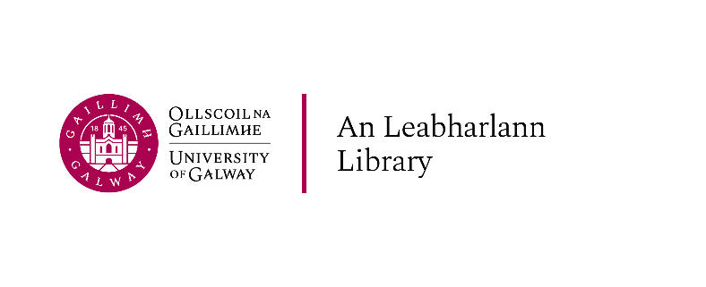

Part-time MakerSpace Student Helper

Academic year 2025-2026

**Vacancy: Part-time Library MakerSpace Student Helper  
Academic Year 2024/25** 

The University invites those who are registered students of University of Galway for this academic year (2025-2026), to apply for a fixed-term part-time temporary position as a MakerSpace Student Helper with the Library.

Applicants must be available to work the assigned hours for the full duration of the contract. The service hours for this position are **16-hours** per week. A work schedule will be determined with the successful candidate, taking into consideration their academic timetable.

The successful candidate will be required to work five shifts from Monday to Friday.

Please send a Cover Letter, CV, recent references and copy of your timetable to eileen.kennedy@universityofgalway.ie by **17:00 on Friday, 8th August 2025.**

You must apply using your University of Galway email account. Late applications will not be considered.

**In person interviews will be held on Friday 15th August 2025.**

Students from non-EU countries, please note that you will need to have your right to work authorised by the immigration office before starting work; you will also need to receive a PPS number from the Revenue before first payment can be issued. More information can be found via the following link, <https://www.internationalstudents.ie/info-and-advice/immigration/working-in-ireland>

**Job Description**

**Part-time Temporary Library MakerSpace Student Helper  
Library, University of Galway**

**Academic year 2025-2026**

## Background to the position

The Library MakerSpace is a place to imagine, learn, fail, make and remake. It is open to all staff and students and provides them with an environment to unleash practical creativity. The MakerSpace contains a suite of PCs and, 3D Printers, a drone, laser cutter, VR headset, Arduinos, Raspberry Pis, and more.

The Library requires a postgraduate student to work in the MakerSpace and provide support to students and staff.

The position offers postgraduate students the opportunity to gain paid work experience in an IT environment. The maximum duration of employment will be 51 weeks.

The successful candidate have responsibility for the following:

* Keep MakerSpace clean and tidy.
* Check equipment in and out.
* Assist in management of 3D printing service .
* Carry out routine maintenance and repairs on 3D printers.
* Carry out routine maintenance and repairs on laser cutter.
* Provide one-to-one assistance to students and staff in the use of MakerSpace tools and technologies
* Assist the MakerSpace manager with maker workshops and events.

## Conditions of Appointment and Duties

Successful candidates will be appointed on a part-time, temporary basis.

## Salary

The salary for this post shall be at point one of the Grade 1 salary scale, your rate of pay will be €26,858 per annum, pro-rata to hours worked. You will be paid by credit transfer monthly in arrears. 

## Contract duration

Contracts will commence on Monday 4th November and finish on Friday, 25th April 2025.

## Hours of work

Contracts are for 16 hours per week Monday to Friday.  The contracted hours are flexible and can be determined to fit a student helper’s timetable so as not to compromise their academic commitments.

## Duties

The MakerSpace student helper will report to the MakerSpace Manager.

* Prepare items submitted for 3D printing for print using UltiMaker Cura and Creality Print software.
* Complete prints and prepare them for collection by patrons.
* Advise patrons on effective design for 3D printing.
* Regularly maintain and troubleshoot 3D printers, including unclogging nozzles, levelling print beds, and replacing cables.
* Advise on use of laser cutter.
* Maintain and troubleshoot laser cutter, including changing air filter, replacing worn or broken parts, cleaning cutting grill.
* Generate statistics on 3D printing and equipment usage.
* Keep MakerSpace tidy and clean.
* Create and maintain support documentation on use of equipment.
* Assist in representing MakerSpace at internal and external events and showcases.
* Maintain a friendly and welcoming atmosphere in MakerSpace.
* Carrying out other duties appropriate to the post as may be assigned by the designated line manager or Library senior manager.

## Qualifications, Experience and Requirements:

### Required:

* Candidates **must be registered students** of the University of Galway for the 2024/25 academic term. (Undergraduate applicants are not eligible for this position.)
* Evidence of successful completion of personal, academic, or professional projects using maker technologies.
* Good working knowledge of standard PC and/or Mac applications and operating systems.
* Enthusiasm for helping people understand making technologies as demonstrated through successful completion of projects adjacent to maker tools, or through customer service / IT support experience.

### Desired:

* Experience working in a customer service environment
* A formal 3rd level qualification in an IT, computer science, engineering, or digital media related area would be desirable
* Candidates must be capable of working in an organised but independent manner
* Experience working with 3D printers
* Experience working with drones
* Experience working with laser cutters
* Experience with Arduino, Raspberry Pi, or similar.