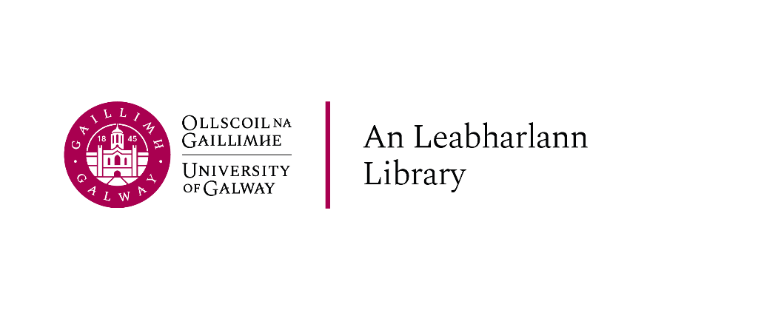

Part-time Academic Writing Centre Tutors

Academic year 2024-2025

Vacancy: Part-time Academic Writing Centre Tutors
Academic Year 2024/25

The University invites those who are registered postgraduate students of University of Galway for this academic year (2024-2025), to apply for a fixed-term part-time temporary position as Academic Writing Centre Tutors with the Library.
The Academic Writing Centre supports students with English and Irish writing along with supporting students with their Scientific Writing. We therefore welcome applications from students who are proficient in Irish and Scientific Writing.
Applicants must be available to work the assigned hours for the full duration of the contract. The service will be available during Semester 1 and Semester 2. The opening hours for the Academic Writing Centre are listed below. The application form is available at https://library.universityofgalway.ie/studenthelper/
To apply for these positions, you must submit:
- A Curriculum Vitae
- A cover letter outlining your interest in the position, your current studies at the University of Galway, and your proposed contribution to the role in the light of your past work experience, career objectives, and knowledge of the work of the AWC and writing centre work in general. Please also indicate whether you are able to work during all the available shifts or specific shifts only
- An academic writing sample (400-500 words) in Irish (if applying for a position of Irish tutor)
- An academic writing sample (400-500 words) in English
Please note all documents must be sent as ONE combined Word document (not a ZIP file) by 17:00 on Monday, 28 October 2024.
You must apply using your University of Galway email account. Late applications will not be considered.
Students from non-EU countries, please note that you will need to have your right to work authorised by the immigration office before starting to work at the AWC; you will also need to receive a PPS number from the Revenue before first payment can be issued. More information can be found via the following link, https://www.citizensinformation.ie/en/social-welfare/irish-social-welfare-system/personal-public-service-number/#l34075

Job Description
Part-time Temporary Academic Writing Centre Tutors – Library, University of Galway
Academic Year 2024-2025

Background to the position
The AWC provides writing support to all University of Galway students, facilitates presentations on academic writing, and runs a number of research and community projects. Tutors will conduct online and in person one-on-one sessions for undergraduate students, take part in other programmes designed to support student writers, and contribute to the development of the AWC through designing materials, modifying existing materials, and running workshops.
The Academic Writing Centre have a number of paid tutoring positions available, these positions offer postgraduate students the opportunity to gain paid work experience in an academic environment.

Conditions of Appointment and Duties
Successful candidates will be appointed on a part-time, temporary basis. The attached terms and conditions of employment will apply.

Salary
The salary for this post shall be €27.04 per hour.

Contract duration
Contracts will commence as soon as possible.

Hours of work
Contracts are between November 2024 and May 2024. The Academic Writing Centre service will be available for 22 hours per week. Tutors can negotiate a schedule of shifts (pattern of attendance) which is semester long that does not compromise their academic commitments.

Academic Writing Centre Opening Hours

 | Monday | Tuesday | Wednesday | Thursday | Friday | Saturday
Daytime | 11:00-15:00 | 11:00-15:00 | 11:00-15:00 | 11:00-15:00 | Closed | 11:00-13:00
Evening | 17:00-19:00 |  | 17:00-19:00
Gaeilge Tutor | 17:00-19:00 | 11:00-15:00 | 17:00-19:00 | 11:00-15:00

Duties
Tutors will report to the Academic Writing Centre Manager and will work collaboratively with the team to contribute to the work of the AWC.
- Tutors will support academic success by working with students individually or in groups to improve academic knowledge and writing skills.
- Tutors will meet with students individually or in small groups to provide support with their writing skills.
- Tutors will participate and lead workshops as required.
- Tutors will research and develop writing aids.
- Carry out other duties appropriate to the post as may be assigned by the designated line manager or Library senior manager.

Qualifications/Experience/Requirements:
- Candidates must be registered post-graduate students of the University of Galway for the 2024/25 academic term
- Demonstrable advanced writing skills, with shown examples of good writing.
- An understanding of the writing requirements of different disciplines and writing genres, e.g. Irish language and Scientific Writing.
- Ability to liaise effectively with students from a wide range of disciplines.
- Being sensitive to student needs and always maintaining confidentiality.
- Ability to work as an effective team member.
- Ability to work independently and demonstrate individual initiative.
- Prior teaching experience is preferred.
- Excellent interpersonal and collaborative skills.
- Excellent organisational skills.
- Committed to creating an engaging, student-centred learning environment.

