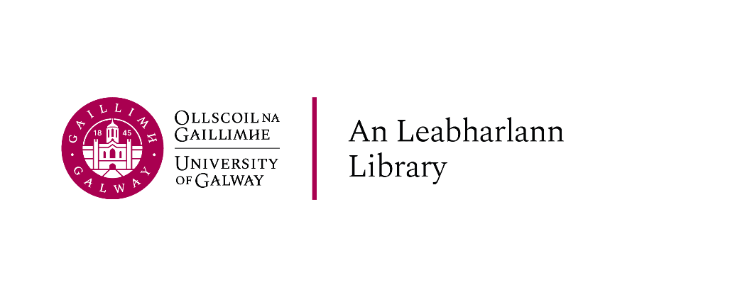

Part-time Academic Writing Centre Tutors

Academic year 2025-2026
Vacancy: Part-time Academic Writing Centre Tutors
Academic Year 2025/26

The University invites those who will be registered postgraduate students at the University of Galway in the academic year (2025-2026) to apply for a fixed-term part-time temporary position as Academic Writing Centre Tutors with the Library. There are English and Irish tutor positions available.
The AWC provides writing support to all University of Galway students, facilitates presentations on academic writing, and runs a number of research and community projects. Tutors will conduct online one-on-one sessions for undergraduate students, take part in other programmes designed to support student writers, and contribute to the development of the AWC through designing materials, modifying existing materials, and running workshops. Applicants should have excellent academic writing and communication skills and a strong interest in pedagogy. Their level of English should be C2 as per the European framework https://www.coe.int/en/web/common-european-framework-reference-languages/level-descriptions
The application form is available at library.universityofgalway.ie/studenthelper
To apply for these positions, you must submit:
- A Curriculum Vitae
- A cover letter outlining your interest in the position, your current studies at the University of Galway, and your proposed contribution to the role in the light of your past work experience, career objectives, and knowledge of the work of the AWC and the fields of peer tutoring and writing centre studies in general.
- An academic writing sample (400-500 words) in Irish (if applying for a position of Irish tutor)
- An academic writing sample (400-500 words) in English

Applicants are advised to select an extract from their work that best showcases their academic writing skills, including argumentation, use of secondary sources, grammar, style. The writing samples or the cover letter must not include any text written by AI.
Please note all documents must be uploaded as ONE combined Word document (not a ZIP file)
You must apply using your University of Galway email account.
Students from non-EU countries, please note that you will need to have your right to work authorised by the immigration office before starting to work at the AWC; you will also need to receive a PPS number from the Revenue before first payment can be issued. (https://www.citizensinformation.ie/en/social-welfare/irish-social-welfare-system/personal-public-service-number/
Information about the AWC can be found at https://library.universityofgalway.ie/studying/awc/
Shortlisted applicants will be invited for an interview, which will include a mock tutorial. Interviews will take place in July, and early September.

