Guide to Map Resources

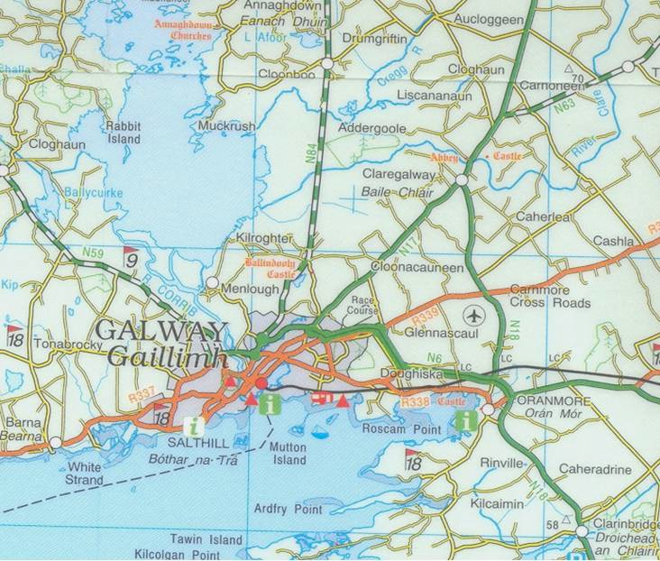

©Special Collections, James Hardiman Library, 2020

Ordnance Survey of Ireland
(beginning with the most recent)

The National Mapping Agreement Service

The Ordnance Survey of Ireland has entered into an agreement with Higher Education institutions to provide many of its maps online, including some not available through the public online digital archive. The University acts as a gatekeeper for this provision. The Library can make login details available to NUI, Galway REGISTERED STAFF and STUDENTS. It is important to note that we are not in a position to support any GIS or other technical queries relating to map downloading and usage. Please email either Marie Boran, the Special Collections Librarian (marie.boran@nuigalway.ie) or Ronán Kennedy, the E-Resources Librarian, (ronan.kennedy@nuigalway.ie) with details of your requirement for access to the site.

Discovery/Discoverer Maps Scale 1:50,000, produced since c.1992, Ireland covered by 89 sheets, several editions of each sheet now available. Located in Map Cabinets A and B in the Map area. Can be viewed online by NUI Galway users at http://geohive.ie/nmaviewer/
Half-inch Maps: Forerunners of Discovery but smaller scale of ½ inch: 1 mile. Produced in 1970s. Located in upright map cabinets under stairs to first floor. You can request assistance from the staff at the library desk with accessing these. Largely superseded by Discovery series.
Cassini Maps: Scale 6-inches: 1 Mile, mostly produced in 1940s. Black & White. Good for tracking the existence of features originally seen on earlier maps. Only available online at http://map.geohive.ie, https://www.archaeology.ie/ and http://geohive.ie/nmaviewer/.

Revised Edition 6-inch: Scale 6-inches: 1 Mile. Black & White. Mostly date from early 20th century but were reprinted up to the 1930s. We only have access to county Galway. Hardcopy, in Map Cabinets E & F in the Map Area.

25-inch Maps: Scale 25-inches: 1 mile. Mostly date from the 1890s up to c.1915 with later printings. Very good for showing individual features in the landscape. Black & White. We have c.3/4 of the series for county Galway in hardcopy but they are in poor condition so we encourage students to use the online version, available on http://map.geohive.ie and on https://www.archaeology.ie/ and http://geohive.ie/nmaviewer/ Note that there are some locations for which these are unavailable.
1st Edition – Scale 6 inches: 1 mile (1838-1842). The first comprehensive series of maps covering the whole of Ireland, which was the first country in the world to be mapped in this manner. We have the whole series in large bound volumes but these can only be consulted by appointment in the Archives & Special Collections Room. This series is available, in both colour and B&W versions, on http://map.geohive.ie, http://geohive.ie/nmaviewer/ and on https://www.archaeology.ie/

Accessing OSI maps in the library

As noted above paper copies of some of the maps are available in the library. In other instances, electronic access is the only means of viewing the map. There are two dedicated PCs in the map area where readers can check maps online. There are also PCs in the Archives & Special Collections Room and in the Special Collections Microfilm Room, though priority on these is given to those consulting digital archives and microfilms respectively. OSI http://map.geohive.ie and http://geohive.ie/nmaviewer/ can be accessed off campus.

Ordnance Survey of Ireland http://map.geohive.ie

Use the zoom on the map to find the location or use the query box at the top of the screen to search for a townland. Use the black menu boxes on the right of the screen to choose which maps you would like to view. Click on the arrow beside “Data Catalogue” on the left to see the various scales of maps available. Tick the box to see each edition.
e.g if you want to look at the colour 1st edition maps (1840-1842 for county Galway), tick the Historic 6” box .It is possible to switch between map editions, e.g 6” and 25” (c.1895-c.1915)

National Mapping Agreement Geohive (NUI, Galway users only) http://geohive.ie/nmaviewer/

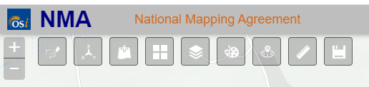

Use the grey tiles at the top of the screen for functionality. The tile on the extreme left allows searching for a location by address or Eircode. The “Window pane” tile allows you to see the various map editions available and navigate between them. The other tiles include draw, measure and saving tools.

Historic Environment and Monument Service
www.archaeology.ie
Choose the “Archaeological Survey Database” tile at the bottom left of the home page

You can search for an address in the search box. You can also click on the “key” symbol at the top of the screen which offers a search box and you can choose a town or townland from the drop-down list. The only snag occurs if that particular townland doesn’t contain an archaeological monument.

The default map is the modern plan. To view other maps click on the “window pane” symbol at the top of the screen, Base-map Gallery will come up. Archaeological and architectural monuments are clearly highlighted on this resource and you can click through to a description where one has been uploaded.

Finding places on Ordnance Survey maps

Ordnance Survey of Ireland hard copy maps have sheet numbers, usually in the top right-hand corner of the map. There are a number of resources you can use to locate the correct map for a location. Probably the easiest one is the online database provided by the Irish Genealogical Research Society at https://www.irishancestors.ie/home-2/. Choose the “Resources” tab near the top of the page and you will find Index of Townlands 1901 under Unique Resources. This page also has good information on the different kinds of administrative divisions within the country.

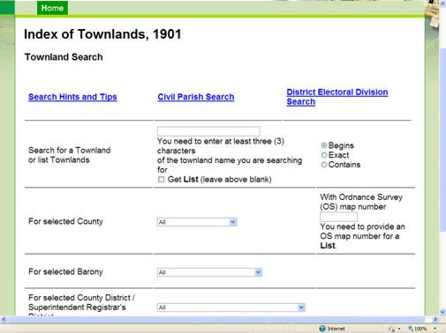

The only snag with this resource is that it doesn’t include the numbers of the Discovery Map sheets which are in a different series to the earlier maps.

Townlands

To get an idea of the location and adjacency of townlands on a map you can consult the Ordnance Survey’s Townlands Index sheets, produced in the early part of the 20th century. These are arranged by county and stored in the upright map cabinets beside the stairs to the first floor. You can request assistance from the staff at the library desk with accessing these.

A Selection of Other Useful Maps

Historical

Griffith's Valuation

Griffith’s Valuation was a property valuation carried out all over Ireland between 1848-1864. Both the actual valuation and the accompanying maps are available online at www.askaboutireland.ie The same data is also available on the Find My Past database to which the library has access. It is possible to search for either a family name or a place name. In the context of most students’ research the latter search would be the more useful. The occupier results for the place will show the original page of the valuation. The numbers in the left hand column relate to numbers on the accompanying maps, links to which appear on the entry.
Note: the maps do not always open accurately, they sometimes open at a nearby townland rather than the one being searched. Also some don't have any demarcation of the individual holdings.

Placenames Database of Ireland

See www.logainm.ie and click on “Resources” then “Toponymy Resources”
Menu on right hand side - Historical Maps by county – e.g Map of county Galway by William Larkin (1819). A useful map that predates the 1st ed. Ordnance Survey by 25 years.

Down Survey Maps of Ireland
The Down Survey is a mapped survey which set out to measure every townland Ireland to be forfeited to soldiers and adventurers following the 17th century Cromwellian “settlement”. The resulting maps, made at a scale of 40 perches to one inch (the modern equivalent of 1:50,000), were the first systematic mapping of a large area on such a scale attempted anywhere. The primary purpose of these maps was to record the boundaries of each townland and to calculate their areas with great precision. http://downsurvey.tcd.ie/down-survey-maps.php

Memorial Atlas of Ireland

Atlas of Irish counties published in 1901 in the USA. Includes a colour map of each county with administrative units called Baronies and Civil Parishes marked. Our digitisation service has created an online version which can be accessed at the Digitised Archives page: http://archives.library.nuigalway.ie/memorial/memorial-atlas.html

Heritage Council of Ireland Heritage Maps
http://heritagemaps.biodiversityireland.ie/#/Map

Sea (Admiralty) Charts

Charts showing depths of water off the coast as well as features such as rocks, islands, harbours etc. We hold a hard copy set in drawer 3 of Map cabinet D
Street Maps & Town Plans

Modern street plans of most major Irish cities are available in hard copy in the 1st drawer of Map Cabinet C in the Map area.

Town Plans
The Ordnance Survey produced large scale detailed maps of towns from the later 19th century onwards. The Library holds a hardcopy series for Galway City, printed in 1872 at a scale of 10 ft: 1 mile. UCD’s Digital Library service has digitized an extensive series of these town maps for most counties in Ireland, including the 1872 and also series from the early 20th century. Details of the towns covered in each counties and links to the map images can be seen at http://digital.ucd.ie/view/ucdlib:40377. The Ordnance Survey continued to update these town plans and the library also holds a series covering Galway city from the 1980s. These are stored in the upright map cabinets beside the stairs to the first floor. You can request assistance from the staff at the library desk with accessing these.

Environmental Maps

Soil Maps

Soil Maps – Teagasc-Environmental Protection Agency Ireland
http://gis.teagasc.ie/soils/map.php
Irish Soils Information System. The site contains various resources, including the new 1:250,000 scale soil association map of Ireland.

Groundwater Maps

Groundwater Viewer – Geological Survey of Ireland http://spatial.dcenr.gov.ie/GeologicalSurvey/Groundwater/index.html
The groundwater resource (aquifer) maps and groundwater protection (groundwater vulnerability) maps are based on field studies, interpretation of existing data, and on other mapping with varying scales of resolution

Flood Map OPW Flood Maps

Maps of Flood hazards and areas of flood risk compiled by the Office of Public Works. http://maps.opw.ie/fhrm

BRITAIN
UK National Archives
Looking for a map. http://www.nationalarchives.gov.uk/maps/maps-family-local-history.htm
Maps for local and family history http://www.nationalarchives.gov.uk/maps/maps-family-local-history.htm

British History Online
Ordnance Survey maps https://www.british-history.ac.uk/catalogue/maps

National Library of Scotland
https://maps.nls.uk/

Booth’s Poverty Maps of London
https://booth.lse.ac.uk/

WORLD MAPS

Open Street maps

OpenStreetMap is built by a community of mappers that contribute and maintain data about roads, trails, cafés, railway stations, and much more, all over the world.
www.openstreetmap.org

Library of Congress Map Collections
https://www.loc.gov/maps/collections/%20:

University of Texas, Perry-Castaneda Library map collection
https://legacy.lib.utexas.edu/maps/

ATLASES

A collection of geographical and other types of atlas is held in the Atlas Collection, usually on the First Floor. Atlases can also be found in the main book collections. Search the Library catalogue on www.library.nuigalway.ie for atlases in your chosen subject.

For help with map queries Contact the Main Library Desk or Staff at the desk in the Archives & Special Collections Reading Room
By email:
Special Collections specialcollections@nuigalway.ie

Marie Boran, Special Collections Librarian, marie.boran@nuigalway.ie

