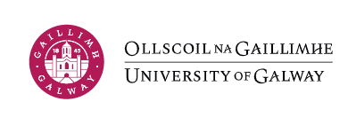

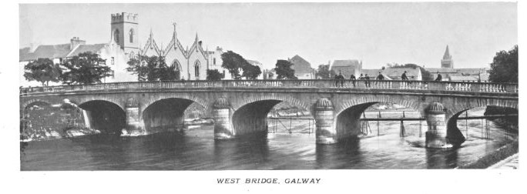

Resources
For the Study of
Irish People and Places

James Hardiman Library

© James Hardiman Library, 2023

Introduction

This guide is an introduction to the wealth of historical sources for research on the history of places in Ireland and the people who lived there. Many of the resources are available online though some are still only in print. Furthermore, some resources are still easier to use in print for the purposes of detailed historical research rather than for one-off name searches. Where access to both formats is available this will be noted in the text.

Book titles mentioned may be searched on the library catalogue (https://library.nuigalway.ie/ ) to locate shelf numbers (for items on Open Access or on the shelves in the Archives & Special Collections Reading Room) or to facilitate requesting.

Databases for which the library pays a subscription are only available to University of Galway readers. These can also be searched and accessed using the library catalogue. Web addresses for resources freely available on the Internet are also noted.

There are some useful guides, both print and online, to Irish place and people resources. John Grenham’s Tracing your Irish Ancestors, (5th ed, 2019) counts as the most detailed though somewhat densely written guide. In particular it has a useful county-by-county guide to resources. Copies are available on Floor 1 in the James Hardiman Library and in the Archives & Special Collections Reading Room. William Roulston’s Researching farming ancestors in Ireland (2021) is equally valuable for recommendations on sources for both people and places. Online access is available to University of Galway readers through the library catalogue and a print copy is held in the Archives & Special Collections Reading Room.
. The Irish Genealogy Toolkit website http://www.irish-genealogy-toolkit.com provides clearly written background information to many resources as well as offering a blog, Irish Genealogy News, http://www.irishgenealogynews.com/ which keeps abreast of developments and new releases of online resources.

Marie Boran, Special Collections Librarian
January 2023
INFORMATION ABOUT PLACES
Population Statistics
From the mid-19th century on, statistical information, extracted from the original census returns which survive for only a very few places, is readily available for towns and townlands. Much of it is contained in the publications of the British House of Commons and is now freely available on the Online Historical Population Reports website, www.histpop.org.
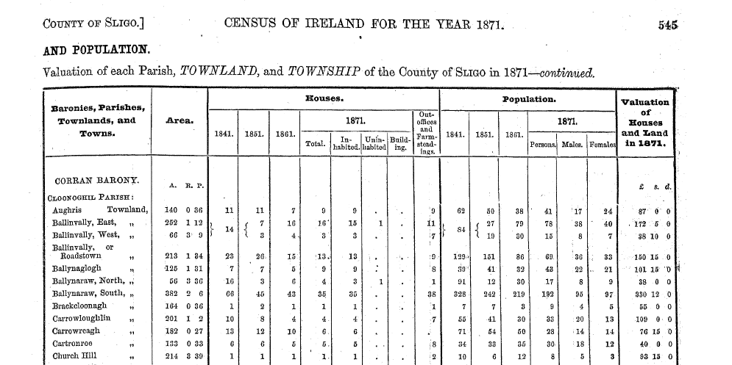

Extract from the statistical tables for the Census of Ireland, 1871, showing townlands in the parish of Cloonoghil, county Sligo

Population statistics from the Censuses taken under the Irish State, starting with 1926, are available in the Official Publications section in the James Hardiman Library and also on the Central Statistics Office website, www.cso.ie

Parliamentary Reports
The House of Commons Parliamentary papers contain a wealth of information on many different topics including education, poverty, trade and economic activity during the 19th and early 20th centuries. Notable reports which include local information are those on Education (1820s), the Condition of the Poor in Ireland (1830s), Landholding (1840s) and the Royal Commission on Congestion (1908). Almost all House of Commons and House of Lords publications are available online on the House of Commons Parliamentary Papers database accessible through the Library catalogue.
Many House of Commons publications relating to Ireland can also be accessed on the freely available Enhanced Parliamentary Papers Ireland website at www.eppi.dippam.ac.uk. Official publications of the Irish State from 1922 onwards can be found in the Official Publications section in the James Hardiman Library, including a full set of debates in Dáil and Seanad Éireann. The latter are also available on www. http://debates.oireachtas.ie/. The debates of the Northern Ireland Parliament at Stormont between 1921-1972 are available online by searching for Stormont Debates on the library catalogue. The record of debates in the Westminster parliament, known as Hansard, is available on the House of Commons Parliamentary Papers database, available to University of Galway readers and which also includes reports described above.

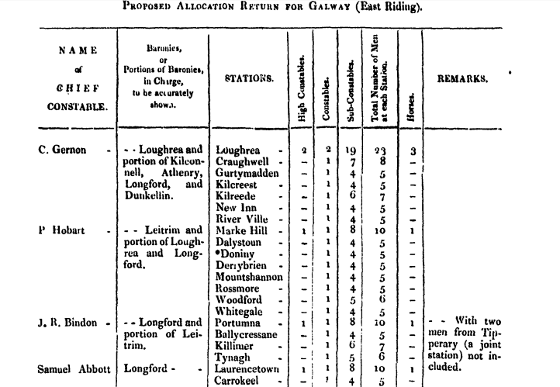

Extract from a memorandum on policing in County Galway, 1840

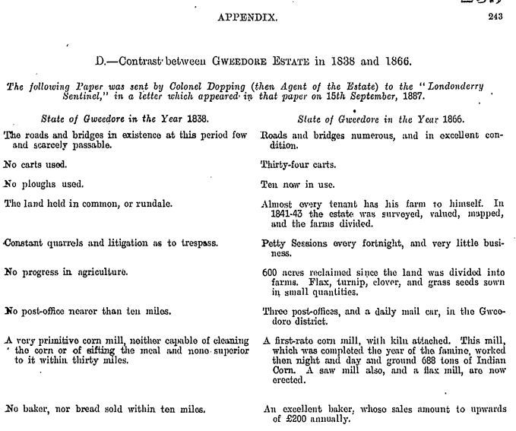

Appendix to 2nd report of the Royal Commission on Congestion in Ireland, contrasting conditions on the Hill estate, county Donegal, 1838 and 1866.
Land & Property
Up until the early years of the twentieth century the bulk of both rural and urban property in Ireland was in the hands of large estate owners. As the 19th century had progressed some urban property had been purchased by those who had made money from industrial or commercial concerns though there is extensive evidence of them also purchasing landed estates. The extensive transfer of property ownership to those who occupied it took place under various Land Acts, most notably the Wyndham Act of 1903, which advanced money to the occupiers to buy their holdings. By 1914 ownership of over 9 million acres had been transferred.

Landed Estates Database
Comprehensive bibliographic information and brief descriptions are available for estates located in the counties which form the provinces of Connacht and Munster by accessing the Landed Estates Database (www.landedestates.ie ) compiled by researchers in University of Galway’s Moore Institute.

Dublin Gazette
This was the regular official publication of the British administration in Ireland. From the 1890s onwards, it frequently records details of estates sold in specific localities and administered by the Irish Land Commission. The indexes at the beginning of each volume include a section under Land Commissioners, entitled “Purchase of Land”, arranged by county. The name of the townland sold as well as the estate owner, the tenants’ names and the amount advanced for purchase are presented in a table. The library’s set includes volumes for the period 1889-1908. Please ask the staff in Special Collections for the year(s) you require.

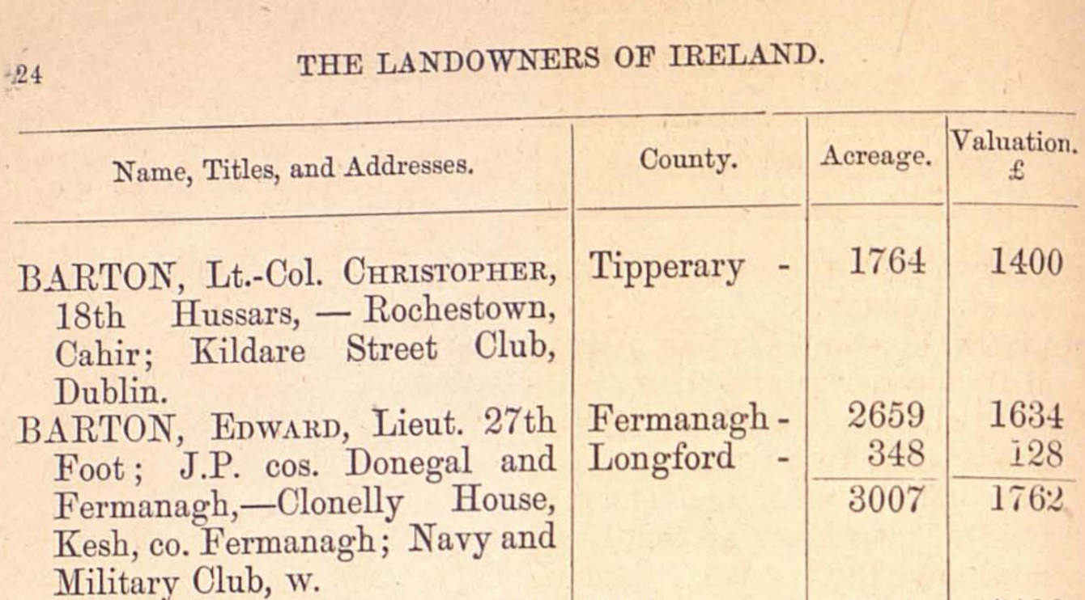

Extract from Hussey de Burgh. The landowners of Ireland (1878)

Surveys of Landowners in Ireland 1876-1888

A number of surveys were undertaken relating to the ownership of land and estates in the later decades of the 19th century. These include John Bateman’s Great Landowners of Great Britain and Ireland (1883), W.H. Hussey deBurgh. The Landowners of Ireland (1878) and Land Owners in Ireland: Owners of 1 acres and upwards, a parliamentary survey published in 1876. Copies of all of these are available in Special Collections. Details of online availability are listed in the bibliography of sources for the history of landed estates in Ireland at the end of this guide.
Landed Estates Court Records 1850-1885
By the mid -19th century many of the large Irish estates were in serious financial difficulty. Land owners found themselves legally obliged to pay out annuities and charges on their land, mainly to pay mortgages or ‘portions’ to family members contracted by marriage settlements and/or wills of previous generations. All of these payments had to be met, before the owner/ occupier could take an income from their estate. The impact of these financial difficulties was compounded by the Famine and the inability of many tenants to pay rent. The Encumbered (later Landed) Estates Court was established in 1849 to facilitate the sale of all or parts of estates in order to alleviate these financial problems.
The Landed Estates Court material takes the form of Sale Notices. These are effectively printed sale-catalogues, which were circulated to prospective purchasers in advance of the sale. They were compiled with the intention of attracting purchasers and of providing information on the estate. The Land Courts sold estates in every county in Ireland, and the documents as a whole cover large parts of the country. The estates sold included urban as well as rural property, and many of the Rentals relate to houses and other buildings in villages, towns and cities.
The title page usually identifies the estate and gives the date and place of the sale. This is normally followed by brief descriptive particulars of the estate and its situation. The descriptive particulars are generally followed by observations and conditions of sale
The Sale Notices frequently contain rentals or lists of tenants, especially the Lot descriptions. These outline the ownership and occupation history of the lot, the quantity of land and the yearly rent that can be charged. Most significantly, they often include the list of tenants, the size of the holding and the terms of tenure.
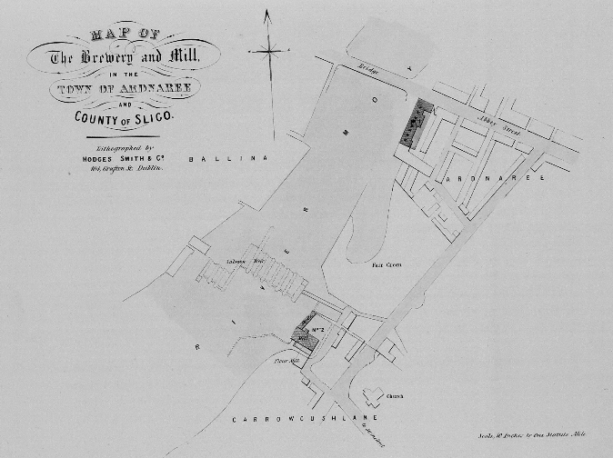

Map of part of the Ardnaree area of Ballina, County Mayo, from the sale of the Verschoyle estate, 1857

Griffith’s Valuation or the Primary Valuation of Ireland
This was a property valuation published for all parts of Ireland between 1847-1864. It provides the names of occupiers of holdings, as well as their size and valuation and details of the person from whom the occupier was leasing. It is commonly called Griffith’s Valuation because the director of the extensive valuing operation was Richard Griffith. The library holds printed copies of the Valuation for the counties of Connacht and parts of many other counties. Almost all of the Valuation is accessible online at the Askaboutireland site, www.askaboutireland.ie.

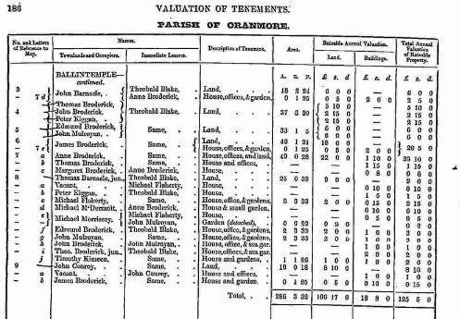

Excerpt from Griffith’s Valuation from the parish of Oranmore, county Galway

Both before and after each publication, manuscript books were produced to record features about the properties and land-holdings, and to record subsequent changes of ownership.
These books – made up of Valuers' Notebooks and Cancelled Land Books (referred to as the Revision Books by the Public Record Office in Northern Ireland) – can be rich sources for advanced research. The Valuers’ Notebooks held by the National Archives of Ireland have been digitised and are available directly through the National Archives genealogy page, http://genealogy.nationalarchives.ie/, under Valuation Office books. They can also be searched and accessed by University of Galway readers on the subscription database Find My Past, via the library catalogue. It is necessary to visit the Valuation Office archives to view the Cancelled Books for the 26 counties of the Republic of Ireland. Advice on this service is available at https://www.valoff.ie/en/archive-research/ The equivalent Revision Books for the counties in Northern Ireland can be viewed online at https://www.nidirect.gov.uk/services/searching-valuation-revision-books
The Notebooks consist of:
- House books, compiled between 1830 to around 1844 and often recording the occupier's name. Note that house descriptions only apply to houses which had a valuation >£5 a year, which excludes the houses of most of the population. Some even include sketches of the property, barns and outbuildings.
- Field Books recorded information about the size of an individual holding and quality of the soil.
- These books were used to gather details between 1830 and the early 1860s though they do not all survive.

Cancelled Land Books
These refer to manuscript volumes in which, following the publication of each volume of the Primary Valuation of Tenements, the Valuation Office recorded any changes to occupier, landlord, size of holding or value for each plot. They cover the period from the publication of the Primary Valuation of the area up to the 1980s.
- At present images of the volumes for counties in the Republic of Ireland can only be viewed by visiting the Valuation Office Research Room in Dublin.
- The Revised Land Books for the six counties in Northern Ireland have been digitised and are available at http://www.proni.gov.uk/index/search_the_archives/val12b.htm. Coloured inks were used to record the changes in ownership of individual holdings

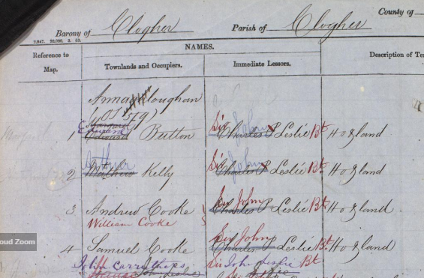

Extract from the Public Record Office, Northern Ireland, digitised Revised Land Books for the townland of Augher, county Tyrone

The archives of the valuation of Ireland by Frances McGee (Dublin, 2018), provides a detailed analysis of all of this material.
Tithe Applotment Books
In the early 19th century occupiers of property which exceeded a certain valuation were obliged to pay tithes [tax] to the local Church of Ireland clergy, regardless of the religion of the occupier. During the 1820s many clergy made lists of those in their parishes who should have been paying this tithe (and frequently were not!) The original lists, known as the Tithe Applotment Books, are held in the National Archives and have been made available in digital format at http://titheapplotmentbooks.nationalarchives.ie/search/tab/home.jsp or through a link on the National Archives genealogy page https://genealogy.nationalarchives.ie/
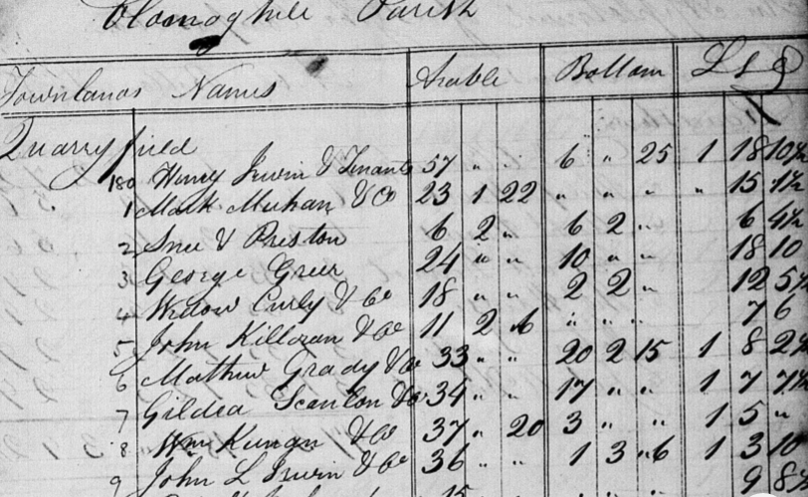

Extract from the Tithe Applotment Book for the civil parish of Cloonoghil, county Sligo

They provide the names of landholders in each townland as well as distinguishing between arable land and that used for pasture or grazing, thereby providing an insight into agriculture at the time.
A related resource is the 1831 List of Tithe Defaulters. The names in these records are of those who refused to pay the tithe and who were recorded by the Church of Ireland clergy. There are 1,061 pages of names of Tithe Defaulters, and 29,027 names. This is a unique record of these people at the time that the various Schedules were compiled, namely, in June, July and August, 1832. During these years opposition to the payment of tithes increased and several serious incidents took place, particularly in the south-east of Ireland, resulting in some fatalities. The list is available to University of Galway readers to search on Find My Past through the Library catalogue.
Ordnance Survey Name Books
The Ordnance Survey Name Books were compiled in the 1830s at the same time that the 1st edition maps were being prepared. These cover every townland in each county. Physical descriptions of the townlands, are noted and explanations of the place names are given. About 16 counties were later produced in typescript form and these volumes are held in the Special Collections Reading Room with the remainder on microfilm at 941.5ODO. The data for county Galway is also available on the county Galway Public Library website http://places.galwaylibrary.ie/
Digitised data for some other counties is available in the Griffith’s Valuation section of the Askaboutireland website (www.askaboutireland.ie) and additions are constantly being made to this collection.

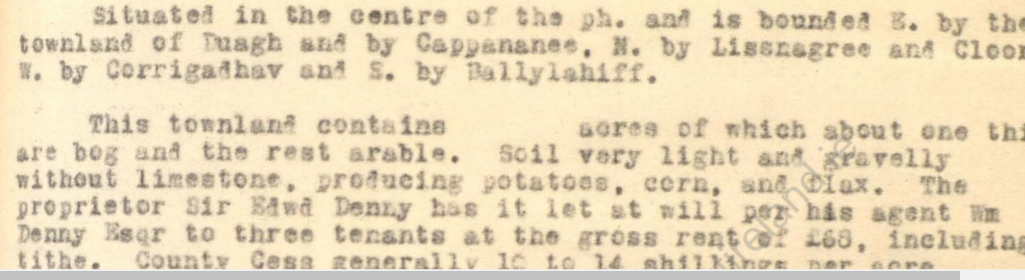

Image from the Ordnance Survey Name Books, townland of Shanthalla, county Kerry

Royal Dublin Society’s Statistical Survey series
The Royal Dublin society promoted county surveys from the 1800s. The intention was that, over time, the full thirty-two counties would be completed but this ambition was never realised. Publication began in 1802 and continued over the next 30 years. The final volume in the series, that for county Roscommon by Isaac Weld, was published in 1832. Connacht was the only province to have all counties surveyed while only two of the Munster counties, Cork and Clare, were published. The volumes contain a snapshot of the economic and social conditions in each county at the time of publication together with recommendations for improvements. The Library holds copies of all of the published surveys, which can be requested and read in the Special Collections Reading Room. Many are also available online through Google Books.

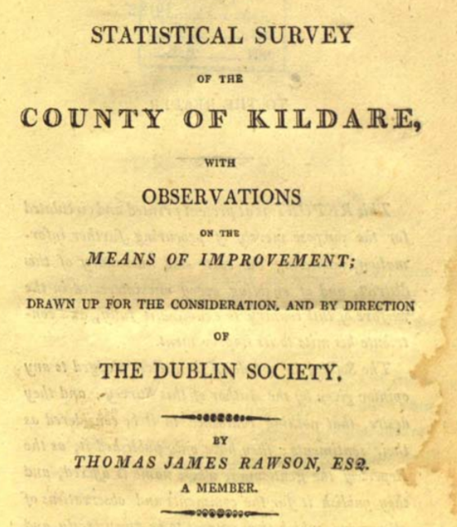

Title page of Thomas Rawson’s Statistical Survey of county Kildare, published by the RDS in 1807

Directories, Gazetteers & Travelogues
Many directories and gazetteers were published about Ireland especially from the 19th century onwards with the expansion in tourist travel. Some are still only available in their original printed form although increasingly, extracts, especially in relation to particular counties, have been reprinted. In addition, some of the complete works have been digitised and are available electronically. Probably the most famous of these publications is Samuel Lewis’ Topographical Dictionary of Ireland (London. 1837). As it contains a description of each civil parish as well as most towns it is a very useful depiction of Ireland before the Famine. The Library holds several copies of this work in both the original and reprinted editions, one set of which is shelved in the Archives & Special Collections Reading Room. The text is available online at https://www.libraryireland.com/, A similar publication is The Parliamentary Gazetteer of Ireland, published in 1846 and also available in hardcopy in the Archives & Special Collections Reading Room.
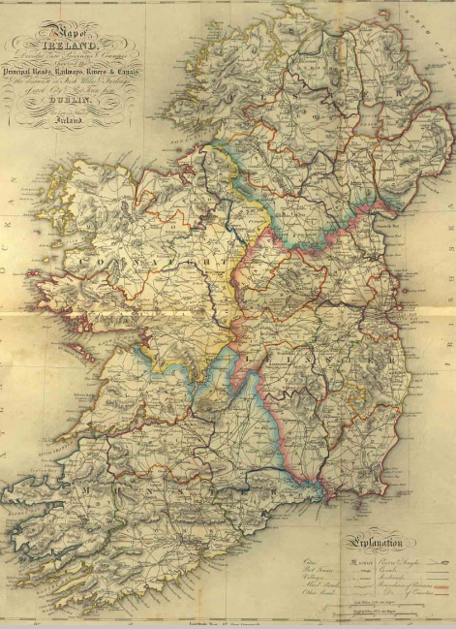
Map from Samuel Lewis’ Topographical Dictionary of Ireland (1837)

As transport became more accessible in the latter half of the 19th century the numbers of visitors increased and there is a corresponding expansion in travel publications, either guidebooks or visitors providing a description of their experiences. Significant bibliographies of these have been compiled including John McVeagh’s Irish Travel Writing: a bibliography (Dublin: Wolfhound Press, 1996) and C.J. Woods. Traveller Accounts as source material for Irish historians (Dublin: Four Courts Press, 2009) both of which are available in the library. Searching the library catalogue using “Ireland Description and Travel” will also find interesting examples of such publications.
Maps of the Roads of Ireland
In 1777 George Taylor and Andrew Skinner published what is essentially the first road atlas of Ireland, Maps of the Roads of Ireland. It is a useful insight into the important towns and routes in the country at that time. Among the most significant landmarks were the houses of the landed gentry indicative of the society in which it was set. The Library holds a copy of the original edition in Special Collections as well as a reprint copy, published by the Irish University Press in 1969. The latter volume is available in the Archives & Special Collections Reading Room. Maps of the Roads of Ireland is available online at www.askaboutireland.ie in their Reading Room Digital Books collection.

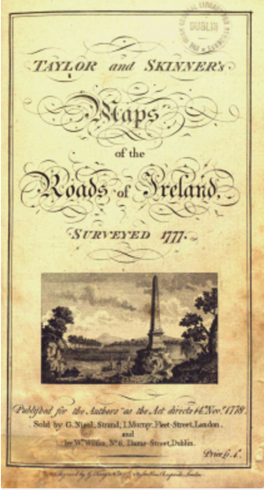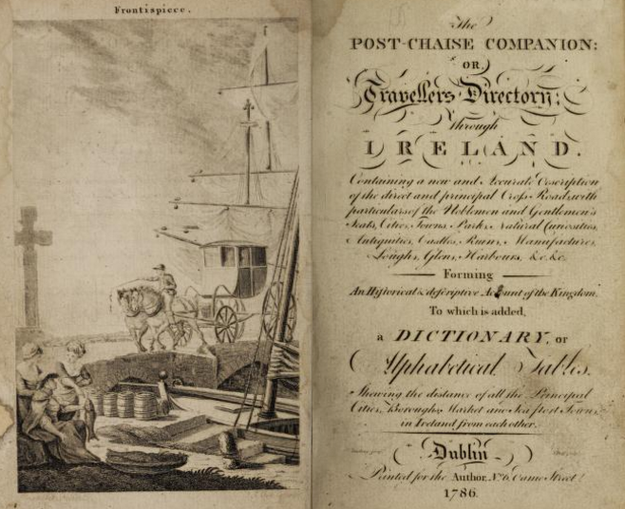

Post Chaise Companion
Using Taylor and Skinner’s maps, William Wilson created a “road book”, essentially a guide-book to the places shown on the maps. The Post-chaise Companion or Traveller’s Directory through Ireland was first published in 1784 and had two further editions in 1786 and 1803.
In addition to mentioning the estates of the landed gentry it also directs the traveller to historic or archaeological sites and to the commercial enterprises to be seen in towns. The library holds copies of the various editions in Special Collections and it is also available online to University of Galway readers through the Eighteenth Century Collections database (accessible via the Library Catalogue).
17th Century Land Surveys
Books of Survey and Distribution
These are the records of the grantees and acreage of estates involved in the Restoration land settlement after 1660. They give the name of the proprietor in 1640/41, number of acres granted under the Act of Settlement and Explanation; names of grantees and particulars of their titles. Those for Clare, Galway, Mayo and Roscommon have been published by the Irish Manuscripts Commission and copies of these are available in the Archives & Special Collections Reading Room. The Manuscripts Commission has also made them available on its website at https://www.irishmanuscripts.ie/digital-resources/ The data for Clare was published in the 19th century and is available online at http://www.clarelibrary.ie/eolas/coclare/history/frost/frost.htm

Civil Survey
The Civil Survey was conducted between 1654 and 1656. It was not carried out in Connacht due to the existence of the earlier Strafford Survey. It listed the owners of land in 1640, and the new owners. The parts which survive have been published by the Irish Manuscripts Commission, covering the counties or parts of the counties of Cork, Derry, Donegal, Dublin, Kildare, Kilkenny, Limerick, Meath, Tipperary, Tyrone, Waterford and Wexford and they are available on its website at https://www.irishmanuscripts.ie/digital-resources/.

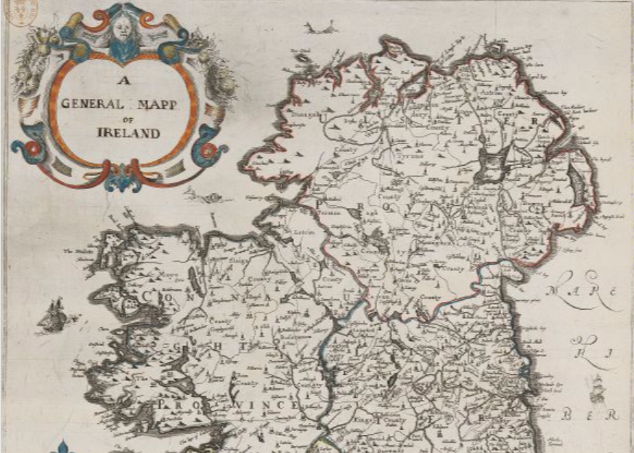
Map from the website of Down Survey of Ireland project website

The Down Survey of Ireland
Taken in the years 1656-1658, the Down Survey of Ireland is the first ever detailed land survey on a national scale anywhere in the world. The survey sought to measure all the land to be forfeited by the Catholic Irish in order to facilitate its redistribution to merchant Adventurers and English soldiers. Copies of some of these maps have survived in dozens of libraries and archives throughout Ireland and Britain, as well as in the National Library of France. The Down Survey project has digitised and gathered together these surviving elements. The maps can be accessed at http://downsurvey.tcd.ie/index.html
Strafford Survey of Connacht
This is the earliest survey that can be identified, carried out in Clare, Galway, Mayo, Roscommon and Sligo. However, all that now survives is a fragmentary map of Roscommon, several maps from Clare and all the text but not the maps for Sligo. The Strafford Inquisition of Co Mayo, listing the landowners recorded at the time, was edited by William O’Sullivan and published by the Irish Manuscripts Commission. The Roscommon maps were published with the Book of Survey and Distribution for that county (edited by R. C. Simington, Dublin, Irish Manuscripts Commission, 1949). Both volumes are available in that collection in the Special Collections Reading Room.

Maps
More information on the maps available in the library for local research can be found on our Maps page at https://library.universityofgalway.ie/collections/specialcollections/maps/.
Digital editions of the various editions of Ordnance Survey of Ireland maps, from the 1830s onwards, can viewed on the OSi website at https://webapps.geohive.ie/mapviewer/index.html using the Mapviewer tab.
The National Library of Scotland provides digital access to a set of maps of Ireland published by the Bartholomew company in the 1940s at https://maps.nls.uk/international/.

INFORMATION ABOUT PEOPLE
Census Research
A census was conducted in Ireland at 10-yearly intervals from 1821. Complete returns only survive, however, from both the 1901 and 1911 Census and these can be searched at http://www.genealogy.nationalarchives.ie/ Fragments of earlier census returns for a small number of locations survive in the National Archives of Ireland and can be searched at the same site where there is also useful background information.

Using the Census records

The How to Search pages provided by the National Archives (http://www.census.nationalarchives.ie/help/help.html) offer detailed advice on searching the census returns. Remember to look at the links to the actual returns (viewable in pdf format) as well as the transcribed information.

TIPs:
• Note the “More Search Options” link on the Search Form. For example, this allows you to discover that there were 4729 people listed as belonging to the Church of Ireland in county Sligo in the census of 1911 or that, in 1901, there were 3298 people in county Kilkenny who claimed to be able to speak both Irish and English.
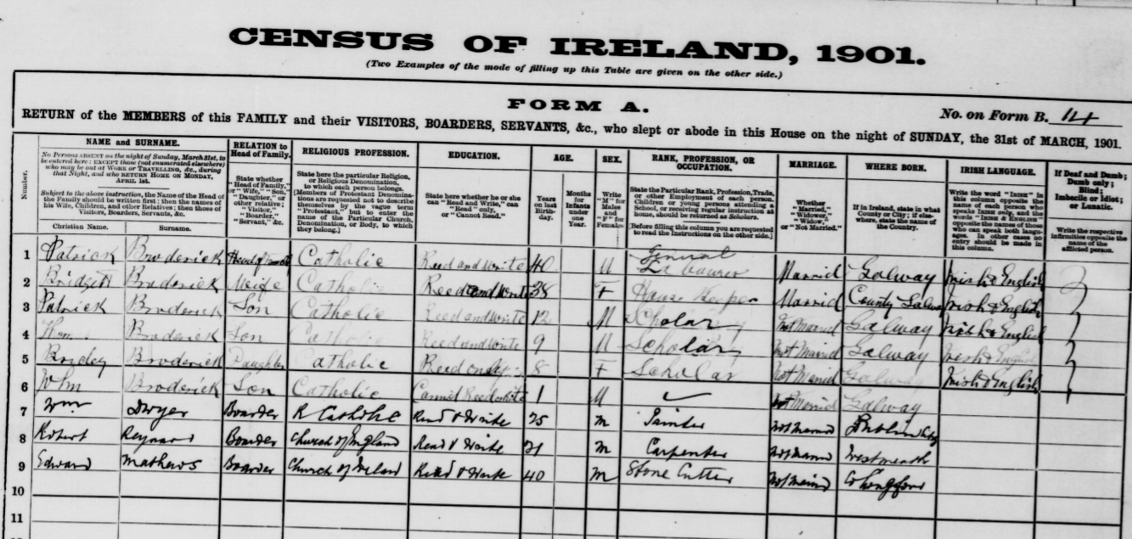

Extract from a household return from the Census of 1901

• Length of marriage information: In 1911 married women were asked how many years they had been married, how many children were born to them and how many of these children were still living. For a family history study the “years married” information allows you to estimate the date of the marriage and then seek a church or civil record for that marriage. Remember that this refers to the “present marriage”.

Census Search Forms
The Old Age Pensions Act 1908 introduced a non-contributory pension for eligible people aged 70 and over. It was implemented from January 1909 in England, Wales, Scotland and Ireland. During the first three months of 1909, 261,668 applications were made in Ireland. By 31 March 1910, 180,974 Irish pensions had been granted. Proof of age was an essential part of the process of application for a pension. Because civil registration of births did not begin in Ireland until 1864, applicants had no official documentation to prove their age. It was decided that searches of the 1841 and 1851 census returns, which survived in the Public Record Office at that time, could produce acceptable documentary evidence of a claimant's age.
The claimant had to provide parents' names and their residence at the time of the census in March 1841/1851. These forms were sent to the Public Record Office where searches were carried out to prove eligibility. When a search could not find the claimant, the form was returned with 'not found' or 'no trace' written on it. Even then, you will sometimes get the claimant's version of his/her family members' names and location in 1841 or 1851. Many searches were successful, and these can often provide the names and ages of every person living in the household at the time of the relevant census. The records now online can be searched by census year, forename and surname of claimant, claimant's address at the time of application, forename and surname of claimant's mother and father, and townland/street, parish, barony and county where resident in 1841 or 1851. These forms can be searched at http://www.genealogy.nationalarchives.ie/
The Public Record Office of Northern Ireland (PRONI) holds Census Search Forms for people living in Antrim, Armagh, Cavan, Derry, Donegal, Down, Fermanagh, Monaghan and Tyrone at the time of their pension applications and include those who had been born or spent their childhood in other counties.
TIP: Even if the applicant’s details were not located on the 1841 or 1851 Census form the often provide the names of their parents, including mother’s maiden name, which can be helpful in finding other information.

Birth, Marriage and Death records

Ireland's earliest civil records date from 1845 when non-Roman Catholic marriages began to be registered. Births, Deaths and remaining types of marriages began to be registered from 1864. A searchable index (with links to most of the actual records) is now available on the free Irish Genealogy site, www.irishgenealogy.ie. A useful detailed account of how to use these records is available on the Irish Genealogy Toolkit website at http://www.irish-genealogy-toolkit.com/Irish-civil-registration.html

Parish / Church Records
For a comprehensive summary of the current availability of church records see the Irish Genealogical Research Society’s summary of Resources at https://www.irishancestors.ie/resources/start-your-research/start-your-research-church-records/
The most important fact to note about Irish church records is the absence of consistency. In some cases there are parish records going back to the 18th century or earlier while in others parish registers only commence in the 1880s. A variety of sites provide transcriptions of data from church records of various denominations, commonly organised by County. These include the free Irish Genealogy (www.irishgenealogy.ie ) and the subscription based Roots Ireland (www.rootsireland.ie ) as well as some data on the subscription websites Ancestry and Find My Past.
The National Library of Ireland has taken Roman Catholic parish records one step further by making available images from its microfilm collection of Roman Catholic Parish registers held there. (www.registers.nli.ie)

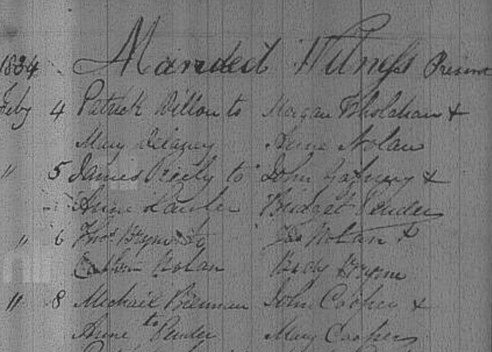

Extract for a marriage from the RC Parish register for Killeshin, County Laois, , available from the National Library of Ireland’s www.registers.nli.ie .

Note: As the images on the NLI site are currently not searchable except by parish it is worthwhile to first use another sourc to identify the date of the event.
Court & Prison Records
From c.1820s until the foundation of the Irish State, the Petty Sessions Court served as the equivalent of the District Court today. Many of our ancestors may have found themselves mentioned in the court records, either as defendants, plaintiffs or witnesses in cases concerning minor crimes and misdemeanours. The records for many of the courts held in what is now the Republic of Ireland are available in the National Archives and have been or are being digitised. They are available to search on the subscription website Find My Past (www.findmypast.ie), to which the Library has a subscription. This resource also contains Prison Registers from prisons located in some counties now in the Republic of Ireland, ranging in date from the late 1790s up to 1924 although most refer to the mid-19th century period.
The surviving records for both Petty Sessions Courts and prison registers in the six counties of Northern Ireland are held in the Public Record Office of Northern Ireland but are not yet digitised.

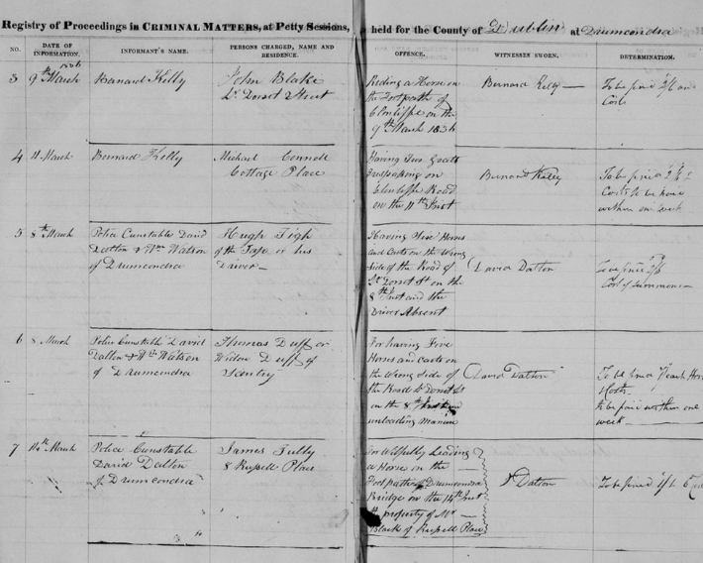

Extract from the register of the Petty Sessions Court held in the County of Dublin
Trade & Commercial Directories
The publication of Slater’s Commercial Directory in 1846 marked something of a departure in commercial listing since it was one of the first to include the names of shopkeepers, artisans and professional persons in local towns in addition to the nobility and gentry who would have been listed in some earlier directories such as that of Ambrose Leet, published in 1824. Other enlarged editions of Slater’s were published in 1856, 1871, 1881 and 1894. All, except the 1856 edition, are available to browse on the subscription service www.findmypast.ie to which the Library has a subscription. The Lbrary holds the hardcopy edition of Slater’s directory for 1856, located in the Archives & Special Collections Room. The free Failte Romhat web site also contains some directories, notably access to Slater’s 1846 edition, at www.failteromhat.com.
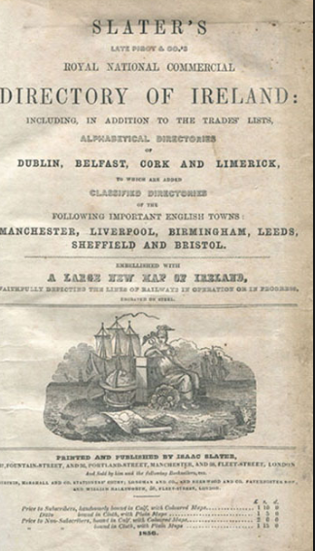

Title page, Slater’s Directory, 1856

Alexander Thom published his first Irish Almanac and Official directory in 1844 and Thom’s Commercial Directories continued to be published into this century. This is a particularly important source for the history of people and places In Dublin City since it contained a street directory with the names of those resident. The most complete print collection of the directories is held in the Dublin Collection of Dublin Public Library service’s Gilbert Library in Pearse St. An online run, covering the years 1844-1900, is available on the subscription service Find My Past (www.findmypast.ie ), available to University of Galway readers through the library catalogue. The early decades of the twentieth century saw Thom’s expand coverage of commercial enterprises to other large Irish cities and towns such as Cork, Limerick and Galway. These directories are also useful for tracking down those working in the judiciary and contemporary local authorities. The Library holds a comprehensive, though incomplete, run of Thoms’ directories. The volumes are available on the shelves in the Archives & Special Collections Reading Room.
Descriptions and links to information concerning directories has been compiled by John Grenham on his Irish Historical Directories page.

Local Studies Books

A large collection of Local Studies books is shelved in the Archives & Special Collections Reading Room. These are arranged in order by Dewey number. Each Irish county has its own Dewey number. To check our holdings prior to your visit, please search the Library Catalogue.
Such works are usually helpful in providing social and contextual background to the places where your family resided in Ireland. Many include old photographs sourced from local residents.

Local Studies Journals
A selection of the main journals published by local historical and archaeological societies is available in the Archives & Special Collections Reading Room. Many of these titles are still only available in print. In most cases issues for the last 5 years are held in the Reading Room while back runs are held in the periodical store in Snipe Avenue. If you need to request a volume from a back run try to get your request in as early as possible in the day as items are retrieved from that store once a day, usually in the early afternoon. Titles are listed on the library catalogue, usually with entries detailing our holdings.

Family History Journals
The main Irish family history journals are also held in the Special Collections Reading Room. These include Irish Roots, The Irish Genealogist, North Irish Roots and Journal of the Irish Family History Society.

The Royal Irish Academy’s Irish History Online database is an invaluable tool for locating information published within these local history journals. It is free to search at https://www.ria.ie/research-projects/irish-history-online. The National Library of Ireland’s SOURCES directory is also useful for tracing articles published in such journals before 1970.

Selected Links & Bibliographies
LINKS [only portals to resources included]

Irish Ancestors
https://www.irishtimes.com/ancestor/browse/online.htm

Irish Genealogy
www.irishgenealogy.ie

Irish Genealogical Research Society
http://www.irishancestors.ie/

Irish Local History E-Books
http://irishlocalhistory.blogspot.ie/

National Archives of Ireland Genealogy Collection
http://www.genealogy.nationalarchives.ie/

SWilson Maps & other local studies resources
http://www.swilson.info/

John Grenham Irish Place Names
SELECT BIBLIOGRAPHY

Note: Copies of these titles are available through the Special Collections & Archives Reading Room. Details of titles also available as e-resources are noted.

Wilson, William. The Post Chaise companion or a traveller’s directory through Ireland. Dublin. 1786. www.books.google.com
Leet, Ambrose. A Directory to the market towns, gentlemens’ seats.in Ireland. Dublin: Brett Smith, 1814.
Pigot’s Directories for Ireland, Scotland and the northern counties of England, 1820-1 and 1822. (microfiche) http://www.failteromhat.com/pigot.htm
Lewis, Samuel. Topographical Dictionary of Ireland. London: S. Lewis. 1837. www.libraryireland.com
Parliamentary Gazetteer of Ireland. Dublin: A. Fullerton, 1846. www.libraryireland.com
Slater’s National Commercial Directory of Ireland. Manchester: Slater, 1856. 1846 edition available online at www.failteromhat.com
Goulding, John. Laois around the famine times; descriptions from Lewis’ and Slater’s directories. Wexford: [the author], 2000
Lewis’ Cork: a topographical dictionary of towns, villages and parishes in Cork city and County originally published in 1837. Cork: Collins Press, 1999. Cork entries also available online at http://www.failteromhat.com/lewis.htm
Lewis, Samuel. County Clare: history and topography from Lewis Topographical Dictionary. Ennis: CLASP Press, 1995 and 2nd edition 2002.
Thom’s Commercial Directory for Ireland, 1849 - (incomplete run).
The Library also holds a large collection of travel accounts of Ireland and elsewhere, many dating from the 19th century. Type “Ireland Description Travel” into the Catalogue. It is possible to limit your results by date of publication.

Surveys
Mason, William Shaw. Statistical account or Parochial Survey of Ireland. Dublin: Graisbery & Campbell, 1814-19. The Library holds volume I only in hardcopy but the entire work is also available online at www.books.google.com

Statistical Surveys published by the Royal Dublin Society
These publications were motivated by a desire to effect improvements in the economy and in agriculture in particular. They often contain descriptions of agricultural and economic practices in specific localities.

(All held in hardcopy in Library Special Collections store and must be requested. Note that some are also available to University of Galway readers from the Making of the Modern World series via the Library Catalogue. Some titles are also on Google Books)

Antrim: Dubourdieu, John. Statistical survey of the county of Antrim Dublin: Printed by Graisberry and Campbell, 1812 www.books.google.com
Armagh: Coote, Charles, Sir. Statistical survey of the county of Armagh, Dublin: Printed by Graisberry and Campbell, 1804 www.books.google.com
Cavan: Coote, Charles, Sir, 1765-1857: Statistical survey of the county of Cavan, Dublin: Printed by Graisberry and Campbell, 1802
Clare: Dutton, Hely. Statistical survey of the county of Clare. Dublin: Printed by Graisberry and Campbell, 1808.
Cork: Townsend, Horatio. Statistical survey of the county of Cork. Dublin: Graisberry and Campbell, 1810.
Donegal: McParlan, James. Statistical survey of the county of Donegal. Dublin: Printed by Graisberry and Campbell, 1802
Down: Dubourdieu, John. Statistical survey of the county of Down. Dublin: Printed by Graisberry and Campbell, 1802.
Dublin: Archer, Joseph. Statistical survey of the county Dublin. Dublin: Printed by Graisberry & Campbell, 1801. www.books.google.com
Galway: Dutton, Hely: A statistical and agricultural survey of the county of Galway. Dublin: Printed at the University Press by R. Graisberry, 1824. www.books.google.com
Kildare: Rawson, Thomas James. Statistical survey of the county of Kildare, Dublin: Printed by Graisberry and Campbell, 1807. www.books.google.com
Leitrim: McParlan, James. Statistical survey of the county Leitrim. Dublin: Printed by Graisberry & Campbell, 1802.
Londonderry [Derry]: Sampson, George Vaughan. Statistical survey of the county of Londonderry. Dublin: Printed by Graisberry and Campbell, 1802. & A memoir explanatory of the chart and survey of the county of London-Derry. London: G. and W. Nicol, 1814
Mayo: McParlan, James. Statistical survey of the county of Mayo. Dublin: Printed by Graisberry and Campbell, 1802.
Meath: Thompson, Robert. Statistical survey of the county of Meath. Dublin: Printed by Graisberry and Campbell, 1802.
Monaghan: Coote, Charles, Sir. Statistical survey of the county of Monaghan. Dublin: Printed by Graisberry & Campbell, 1801.
Weld, Isaac, Statistical survey of the county of Roscommon. Dublin: Royal Dublin Society, 1832 & online access at www.books.google.com
McParlan, James. Statistical survey of the county of Sligo. Dublin: Printed by Graisberry and Campbell, 1802. www.books.google.com
McEvoy, John. Statistical survey of the county of Tyrone. Dublin: Graisberry and Campbell, 1802 www.books.google.com
Fraser, Robert. Statistical survey of the county of Wexford. Dublin: printed by Graisberry and Campbell, 1807 www.books.google.com

SOURCES FOR THE HISTORY OF LANDED ESTATES IN IRELAND
Please check the Library catalogue for shelf details for these titles. Items available as e-resources are noted.
NOTE: For comprehensive information relating to the landed estates which existed in the counties of Connacht and Munster, c.1700-c.1914 check the Irish Landed Estates database at www.landedestates.ie

Modern Printed Sources

Bunbury, Turtle. The landed gentry & aristocracy of County Kildare. (Bunclody: Irish Family Names, 2004).
Bunbury, Turtle. The landed gentry & aristocracy of County Wicklow. (Dublin: Irish Family Names, 2005).
Bary, Valerie. Historical, genealogical & architectural notes of some houses of Kerry. (Whitegate: Ballinkella Press, 1994)
Bence-Jones, Mark. A guide to Irish Country Houses. 2nd ed. (London: Constable, 1990)
- Life in an Irish country house. (London: Constable, 1996).
- Twilight of the Ascendancy. (London: Constable, 1987)
Dooley, Terence. The decline of the “Big House” in Ireland. Dublin: Wolfhound Press, 2001.
- The Big Houses and Landed Estates of Ireland: a research guide. (Dublin: Four Courts Press, 2007).
- Burning the Big House: the story of the Irish country house in a time of war and revolution (New Haven: Yale University Press, 2022)
Eiriksson, Andres & Ó Grada, Cormac. Estates Records of the Irish Famine: Guide to Famine archives 1840-1855. (Dublin: 1995)
Grenham, John. Tracing your Irish Ancestors. (5th ed. Dublin: Gill & Macmillan, 2019)
Griffin, David, Robinson, Nicholas. Vanishing country houses of Ireland. (Dublin: Irish Architectural Archive, 1989)
Hajba, Anna-Maria. Historical, genealogical & architectural notes of some houses of Cork: Volume I: North Cork. (Whitegate: Ballinakella Press, 2002)
Hayes, William J. & Kavanagh, Art. The Tipperary gentry. (Dublin: Irish Family Names, 2003).
Kavanagh, Art & Murphy, Rory. The Wexford gentry. (Bunclody: Irish Family Names, 1994-1996).
Kavanagh, Art. The Landed gentry and aristocracy of County Meath. (Dublin: Irish Family Names, 2005).
Marsden, Simon. In ruins: the once great houses of Ireland. (London: Collins, 1980).
Montgomery Massingberd, Hugh. Burke’s Irish Family Records. (London. 1976, Reprinted 2007)
O’Toole, Jimmy. The Carlow gentry. (Carlow: the author, 1994)
Rowe, David & Scallan, Eithne. Historical, genealogical & architectural notes of some houses of Wexford. (Whitegate: Ballinakella Press, 2004)
Weir, Hugh W.L. Historical, genealogical & architectural notes of some houses of Clare. (Whitegate: Ballinakella Press, 1999)
Burke’s Landed Gentry of Ireland. [Various editions, 1912 usually regarded as the most comprehensive, available online at www.archive.org ]

Contemporary Printed Sources
Simington, R.C. Books of Survey & Distribution. (Dublin: Irish Manuscripts Commission, 1949-67). [Counties Clare, Galway, Mayo & Roscommon]
Pender, Seamus (ed). Census of Ireland, c. 1659. (Dublin: Irish Manuscripts Commission, 1939).
Goblet, Y.M. Topographical Index to townlands mentioned in Sir William Petty’s Maps 1655-59. (Dublin: Irish Manuscripts Commission, 1939)
Taylor, George & Andrew Skinner. Taylor and Skinner’s Maps of the Roads of Ireland surveyed 1777. (London. 1778) [reprinted by the Irish University Press, Shannon, 1969] [Available at www.askaboutireland.ie Digital Book Collection]
Griffith, Richard. Primary Valuation of tenements in Ireland (Griffith’s Valuation). Dublin: A. Thom, 1848-1864. [Available at www.askaboutireland.ie and on Find My Past ]
Charles Charlesworth. Index to Rentals of Properties sold in the Encumbered and Landed Estates Court, 1849-1864. (Dublin; National Library of Ireland. [Microfilm copy available in Special Collections]
House of Commons. Return of Owners of Land of One Acre and Upwards. (Dublin. 1876) available in Special Collections Reading Room. www.dippam.ac.uk
Hussey de Burgh, U. The Landowners of Ireland (Dublin. 1878). [Available in Special Collections and at www.askaboutireland.ie ]
J. Bateman. The Great Landowners of Great Britain and Ireland. (London. 1879) [Available in Special Collections and at www.books.google.com ]
Walford, Edward. The County Families of the United Kingdom. (London. 1860) [Available in Special Collections and at www.archive.org ]

For further information, contact:
Marie Boran, Special Collections Librarian

Email: marie.boran@universityofgalway.ie
Tel: 091-492543
Visit the Special Collections web pages at http://www.library.nuigalway.ie/specialcollections/

